The effect of lengthy terms and conditions on consumer attention and perceptions
A study prepared by the radio advertising bureau
November 2013
INTRODUCTION
Terms and conditions occur in adverts for a range of products and services. Also sometimes referred to as legal caveats or risk warnings, their primary purpose is to ensure consumers are able to make informed decisions about whether or not to purchase goods without being misled.
Terms and conditions appear in the small print in press adverts, in the text at the bottom of the screen in TV adverts and, in the case of radio, they are read out in real-time, usually at the end.
WHICH SECTORS ARE MOST AFFECTED?
In spring 2013 the RAB carried out an analysis of 150 radio scripts containing terms and conditions. This demonstrated that four sectors in particular carried the longest ts and cs based on average number of words per script : finance, motors, retail and telecoms (Fig 1)
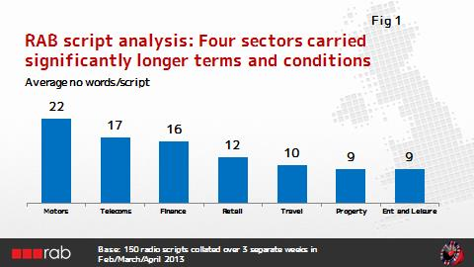

Within this, financial offers relating to consumer credit (motors, retail and financial services) generated terms and conditions containing an average of 24 words – almost twice as long as the average for all sectors (Fig 2). This can add a further 10+ seconds to a radio advert.

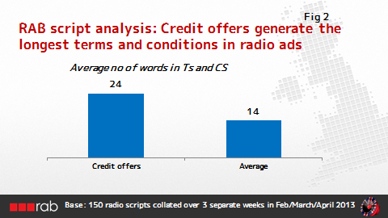

WHAT DO WE ALREADY KNOW ABOUT THE EFFECT OF LENGTHY TERMS AND CONDITIONS?
Two research studies in particular have helped further understanding of the effectiveness of terms and conditions or legal caveats.
1. Navigator Research: Radio Commercials and Wealth Warnings: 2004
This qualitative research study explored the role of advertising in the decision-making process for financial products and within this the role of legal caveats or wealth warnings.
A number of important findings came out of this study, including the following:-
- Advertising was seen as an important early stage in decision-making, guiding consumers to which brands or products they should consider and which features to look for.
- All respondents were aware of wealth warnings and felt they tended to work differently depending on the medium
- However on the whole they felt they paid little attention to them at this stage in the decision-making process
- Furthermore they also regarded them with some cynicism as being there to protect the provider not the consumer.
2. Ipsos-MORI: Making Consumer Credit Markets Fairer – Payday lending advertising research conducted for BIS: Oct 2013
This new study included a mix of qualitative discussion groups and depth interviews. Its aim was to explore uses and perceptions of payday lending and views on payday lending advertising. It also included an exploration of consumer reactions to different types of proposed risk warnings for payday lending adverts.

The key headlines as they related to advertising and risk warnings were:-
- All respondents were aware of payday lending advertising and had seen many examples, particularly on TV.
- All recognised the importance of ensuring potential customers were protected from the risks associated with payday loans by helping them make more informed decisions.
- However they also felt uncomfortable about risks and costs of lending being expressed in adverts using percentages and complex figures.
- This aversion to figures was partly because they lacked confidence in understanding what the figures meant but also because they did not expect this level of complex information in adverts – preferring to source the detail elsewhere (e.g. on the lender’s website)
- Reactions to specific prompts on different types of risk warnings also provided some valuable insights:
  - Respondents were strong advocates of a more personalised warning to appeal to the individual rather than the social norm. So for instance they preferred a warning such as “Think! Could you afford to pay back this loan?” rather than referring to the fact that 2.6 million payday loans were not paid back in time in 2012
  - They also supported the concept of signposting to the Money Advice Service for help
  - Whilst they did not advocate the use of complex figures (APRs etc) the most important single figure for them was the total cost of credit – this tended to be the first thing they would seek out on the lender’s website.
All of the findings from this study reinforce earlier learnings. They confirm that the simpler and clearer the information provided in any risk warning, the more effective it will be.

NEW ANALYSIS – USING THE RAB’S RADIOGAUGE DATABASE TO ENHANCE UNDERSTANDING THROUGH QUANTITIVE EVIDENCE
Background
The two research studies outlined above suggested that longer or more complex terms and conditions in advertising were less likely to be effective, either because consumers won’t pay attention to them or because they can’t absorb or understand the detail.
However, to date there hasn’t been a study specifically aimed at quantifying the real difference this can make. With this in mind the RAB decided to investigate whether their extensive radioGauge database could help identify any significant patterns across a range of adverts carrying terms and conditions.
Analysis objectives
The main objective of the analysis was to identify whether adverts carrying longer ts and cs performed differently against key measures.

What is radioGauge?
radioGauge is the RAB’s on-going campaign effectiveness measurement tool. Using matched split samples of commercial listeners vs non listeners it allows us to isolate radio’s uplift effect for each campaign and then compare with the averages across the wider pool.
In addition to key effectiveness measures (awareness, consideration) radioGauge looks at a number of creative measures, including the RAB’s 5is of effective creativity (Involvement, Identity, Impression, Information, Integration). This enables advertisers to link performance back to their creative execution in order to identify any areas for potential improvement.
How were we able to use radioGauge in this analysis to quantify the effect of terms and conditions?
The RAB’s radioGauge database includes over 550 campaigns where each advert has been tagged according to 21 different creative features. This includes whether it carries short, long or no terms and conditions. 239 out of those 550 campaigns on the database included some form of terms and conditions. This gave us a reasonable sample base to analyse any differences in trends.
And now for our own caveats!
The radioGauge database, when it was originally created, wasn’t specifically set up to focus in detail on the effect of different lengths of terms and conditions on creative and effectiveness measures. So the definitions against which the terms and conditions were tagged were fairly general : long ts and cs were defined as taking up more than 5 seconds or more than 14 words (this is in line with the average numbers of words for scripts containing ts and cs – fig 2); shorter ts and cs were defined as 5 seconds or less.
As illustrated above, there are many examples of scripts where the terms and conditions exceed 5 seconds – some can easily run to over 10 seconds or longer. We would assume therefore that the trends from this analysis will be significantly underplaying the effect of much longer ts and cs. We have tried to address this in part by taking an example of an engagement trace for an ad with 10 seconds of terms and conditions at the end to illustrate the difference in effect.
Summary of the key findings
Finding 1: Longer terms and conditions had little effect on ad awareness
Uplifts in ad awareness showed similar patterns whether listeners were exposed to adverts with shorter, longer, or indeed no terms and conditions. However there are early indications that the fewer ts and cs included in an advert, the greater the increase in positive consideration for the brand.
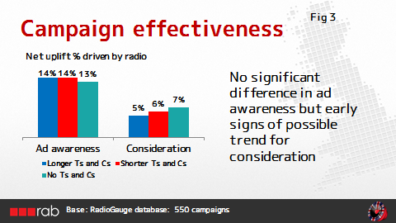

Finding 2: Consumers are less likely to actively engage with or remember the content of adverts with longer ts and cs.
The chart in fig 4 below shows the variations in average creative scores compared to adverts with no ts and cs. Scores for the ads with longer ts and cs were noticeably lower on a number of metrics, suggesting that listeners were less likely to engage with and remember the details. Particular metrics where ads with longer ts and cs underperformed were:
- Involvement (the extent to which consumers will notice and listen to an advert)
- Identity (the extent to which it is clear who the advert is for and how likely listeners are to remember it)
- Impression (does the advert make them feel positive about the advertiser and including the extent to which the advert is felt to be annoying)

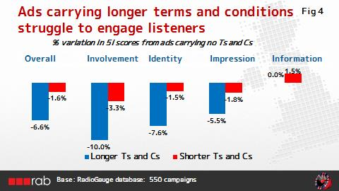

Finding 3: RadioGauge’s engagement trace shows that attention levels fall away at the end of adverts carrying longer terms and conditions.
The engagement trace in radioGauge is a measure of how much attention listeners are devoting to the advert whilst listening to it. It provides vital clues for advertisers on which parts of their adverts are grabbing listener attention and where listeners are likely to “zone out”.
The chart below demonstrates the average engagement trace across all radioGauge campaigns (the green line) compared to the average engagement trace for radioGauge campaigns carrying ts and cs longer than 5 seconds (the red line).
A drop in attention is clearly visible in the last 5 seconds of the adverts with longer ts and cs (red line) whilst in the case of the radioGauge average engagement continues to rise. In those last 5 seconds attention levels for campaigns with Ts and Cs longer than 5 seconds are approx. 20% lower.

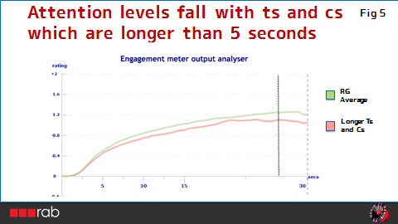

Finding 4: Listeners are likely to “zone out” even further when adverts have much longer and more complex terms and conditions
Bearing in mind that the definition of longer terms and conditions for this analysis is over 5 seconds, the drop in attention levels illustrated above is likely to be a fraction of the drop in attention levels for adverts with much more complex terms and conditions. To illustrate, the chart below is for a car advert (Peugeot) where the last 10 seconds of the 30 second advert is taken up entirely by ts and cs.
Here the engagement trace for Peugeot (again the red line) begins to fall away sharply as soon as the terms and conditions start – dropping by over 50% by the end of the advert. And, whilst the Peugeot advert significantly outperforms the radioGauge average for the first 20 seconds, by the end of the advert its engagement trace score is 30% below the radioGauge average.
In other words listeners are simply zoning out of the terms and conditions, reinforcing the findings of the earlier Navigator Research.
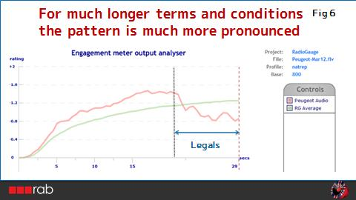

IN SUMMARY
Two valuable studies have already indicated that the simpler and clearer the terms and conditions or risk warnings are, the more effectively they are likely to resonate with consumers and land key messages.
This subsequent analysis of the RAB’s radioGauge database further reinforces these findings by adding some quantitative proof of the effect of longer length terms and conditions in radio adverts. In particular it demonstrates that
- Listeners are much more likely to zone out and ignore longer ts and cs
- Listeners are also much less likely to engage with and remember adverts where longer terms and conditions are included
CONCLUSION
Based on all the evidence to date, if the primary purpose of terms and conditions in advertising is to protect consumers and ensure they make informed choices, it is important to ensure that the ts and cs are kept as clear and focused as possible.
Collectively, the RAB has substantial expertise and insight into best practice advertising and radio advertising in particular and we are happy to work with advertisers and regulators alike to identify opportunities where the effectiveness of terms and conditions or legal caveats can be increased in the interests of consumer protection.
Meanwhile, from an advertiser’s perspective, we would recommend avoiding over-compliance at all costs as this can only further dilute the effectiveness of any required terms and conditions.

