Improving the effectiveness (consumer attention and understanding) of legal caveats and risk warnings in radio advertising
Research study by the Radio Advertising Bureau
BACKGROUND
Many advertisements carry legal caveats. Also sometimes referred to as terms and conditions or tags, they appear in the small print in press advertising, in the text at the bottom of TV advertisements and in the case of radio they are read out loud, usually at the end of the advertisement.
Their purpose is to ensure consumers are able to make informed decisions about whether to purchase a product or not. In the case of financial advertising, legals can also extend to risk warnings which are designed to protect consumers by making them aware of any risks associated with financial products.
WHY THIS RESEARCH?
One of the challenges of any legal caveats or risk warnings is ensuring that consumers take out the important messages without being overloaded with too much information. This is particularly true of financial offers where the tags can include very complex and detailed information.
A number of research studies to date have already indicated that consumers often don’t pay attention to detailed legals within financial advertisements, nor do they expect them.
A recent analysis of the RAB’s radioGauge database also indicated that radio ads with longer terms and conditions performed less well against important metrics, including listener attention.
However, quantitative research to directly explore the effects of different lengths and complexity of terms and conditions has been limited, hence this research.
The research focuses on financial advertising for two reasons:-
- Financial advertising invariably carries some of the most complex and lengthy legals.
- Consumer credit is currently under review by the Financial Conduct Authority as they take on full responsibility from the OFT and in the last year has been the subject of a lot of debate, particularly relating to payday loan advertising.

OBJECTIVES OF THE RESEARCH
To measure whether simpler, shorter legal caveats and risk warnings in financial advertisements can engage consumers and land key messages more effectively than their longer, more complex counterparts.

WHAT TYPES OF LEGAL CAVEATS DID WE LOOK AT IN THE STUDY?
To keep this study as simple as possible we have focused on two types of financial advertisements:-
- Credit advertisements
Consumer credit offers can generate some of the longest terms and conditions. The inclusion of any information relating to cost of credit necessitates a full representative example. Representative examples are both complex and long so an excellent test of just how much consumers can retain and understand when compared to a simpler alternative.
- Payday loan advertisements
To ensure consumers are aware of the risks of payday loans, the Financial Conduct Authority have recommended in their recent consultation the inclusion of a risk warning. The wording of this already adopts clear, consumer-friendly language although it does still ad some 12-14 seconds to the end of a radio ad so this research provided an opportunity to test against a simpler alternative.

METHODOLOGY
The research comprised an online survey of 800 respondents, all Commercial Radio listeners.
Two radio advertisements were taken which had aired in 2013: one for consumer credit (in this case a Ford offer), the other for a payday loan company (Wonga)
For each advert we recorded two different versions of the legals at the end:-
- a full version reflecting the current or proposed legal requirement
- an edited alternative focusing on critical information only (see figures 1 and 2 below)
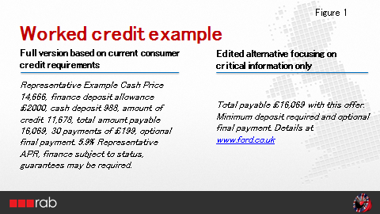

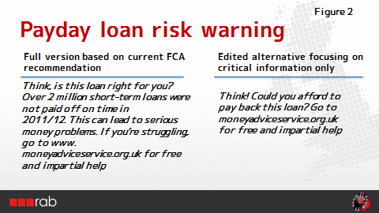

The sample was divided into 2 groups, with each respondent being played two adverts – a consumer credit advert and a payday loan advert. This was to avoid any priming resulting from respondents hearing two different variations of the same advert:

Copy rotation schedule
Group 1
- Payday loan ad with shorter tag
- Consumer credit ad with shorter tag
Group 2
- Payday loan ad with longer tag
- Consumer credit ad with longer tag
Ads rotated evenly within each group

After hearing each advert respondents were asked a series of questions relating to their perceptions of the ad as a whole followed by more specific questions about the terms and conditions.

RESULTS - CONSUMER CREDIT AD
Finding 1. The edited version of the consumer credit ad was more likely to positively engage listeners.
The % of listeners who strongly agreed with statements such as “I would listen to it”, “speaks my language” and “made me feel positive about the brand” were higher when listeners were exposed to the edited version (+13% relative increase).
Finding 2. The full credit version was over 50% more likely to annoy listeners
Respondents were over 50% more likely to strongly agree that they found the ad annoying when exposed to the full credit example (fig 3). Although respondents were being asked about the advert as a whole, the only difference between the two executions is the ts and cs so we can assume that this difference is purely down to the latter.
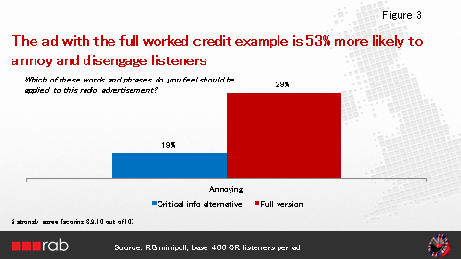
The extent to which adverts are seen as annoying is an indication of how much listeners are likely to switch off or zone out rather than pay attention to them, thus defeating the primary purpose of the terms and conditions which is to inform consumers of the essential information. This reinforces previous research findings e.g. the Navigator study.
Finding 3. The edited version landed key information more effectively
Both executions were seen as equally “informative”. However the edited version which focused on the critical information only was 30% more likely to be seen “as clear and easy to follow”. Also, whilst in both cases high numbers of respondents (over 70%) had noticed the terms and conditions, the edited version was 17% more likely to be seen as helpful.
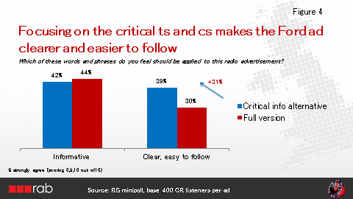
Finally, when respondents were asked what they remembered about the terms and conditions, they were twice as likely to be able to quote the total cost of credit when they had heard the edited version compared to the full version. 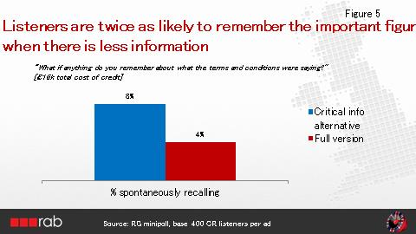

Note however that in neither case does the percentage of those quoting back the total cost of credit rise above 10% - previous research has suggested that consumers are highly unlikely to notice or retain figures.

RESULTS - PAYDAY LOAN RISK WARNING
Finding 1. Both executions engaged listeners equally
We saw little difference in key measures such as “I would listen to it”, “speaks my language” and “makes me feel positive about the brand”. The same was true for how many people saw the ads as “annoying” (figure 6). The fact that both executions use consumer-friendly language will have contributed to this.
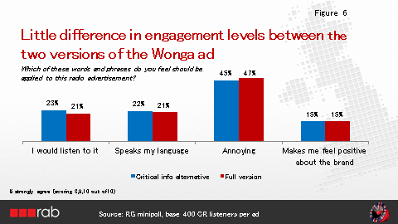

Finding 2. The more focused execution landed the most important messages more effectively
Both executions were seen as “informative” and “clear/easy to follow”, again reflecting the clear, simple language used. But when respondents were asked about what they remembered about what the terms and conditions were saying, a different pattern began to emerge.
Two important messages stood out when listeners were exposed to the more focused execution: – “Can you afford to pay back this loan?” and “Go to www.moneyadviceservice.org.uk for free and impartial help”. Recall of these messages was 38% higher than recall of the equivalent messages from the full version (figure 7 below).
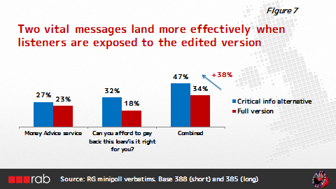

Finding 3 - very few people remembered the number quoted in the full version
Only 3% of respondents recalled that 2 million loans which were not paid back in 2012

IN SUMMARY
Results from this study clearly demonstrate the value of ensuring any legal caveats or risk warnings focus on critical information only in order to ensure that consumer absorb key messages.-
When risk warnings or legal caveats are more focused:-
- Consumers are more likely to respond positively to the advertising rather than switch off
- Consumers are also more likely to find the terms and conditions clear and helpful
- Most importantly they are more likely to notice and remember the critical facts to help them make informed decisions.

CONCLUSION
The over-arching message from this study is that the simpler and shorter the information, the more likely listeners are to engage with the advert and remember the important information concerning risks or specific terms and conditions.
Our recommendation for advertisers therefore is to try to minimise complex and lengthy terms and conditions as much as possible and certainly think hard before adding caveats beyond those required by the regulators.
For regulators we would recommend giving consideration to ensuring legal caveats or risk warnings are kept as clear and focused as possible and take into account how much information consumers can realistically be expected to absorb at this early stage in the decision-making process.
Finally, although this study looks specifically at financial advertising (consumer credit offers and payday loans), many of its findings will be equally relevant to other sectors where detailed and lengthy terms and conditions appear.

Navigator:Radio Commercials and Wealth Warnings 2004 and Ipsos MORI: Payday Loan Advertising Research Oct 2013
RAB: The effect of lengthy terms and conditions on consumer attention and perceptions

